Landing page



Hospital Management System

'

[http://www.hms.cnm](http://www.hms.cnm/)





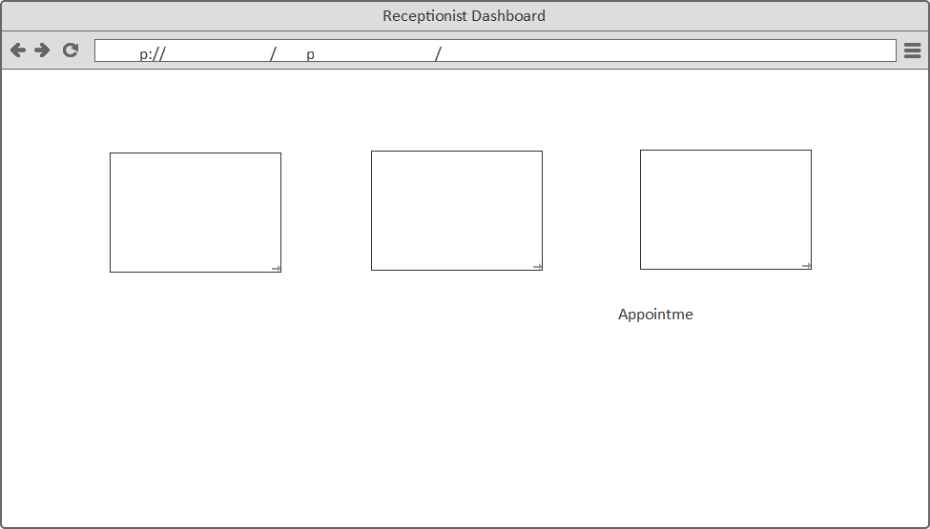Receptionist Dashboard

htt [’www.hms.com](http://www.hms.com/) das/ patient

New Patient Registrant Exning Patent History/Search Check Doctor Availability/Book

Patient result

Patient Search



Unique Patient ID

1024

Search Results

— Patient Details Name: ishal

eddV

Marital Status: -

Address: House no 8 2

ABC Colony S Due Amount  Telangana

Date 12/3/2019

Labreport

PriscriptJist

Doctor

Dr. Gowtham

Book Appointment

Make

payment

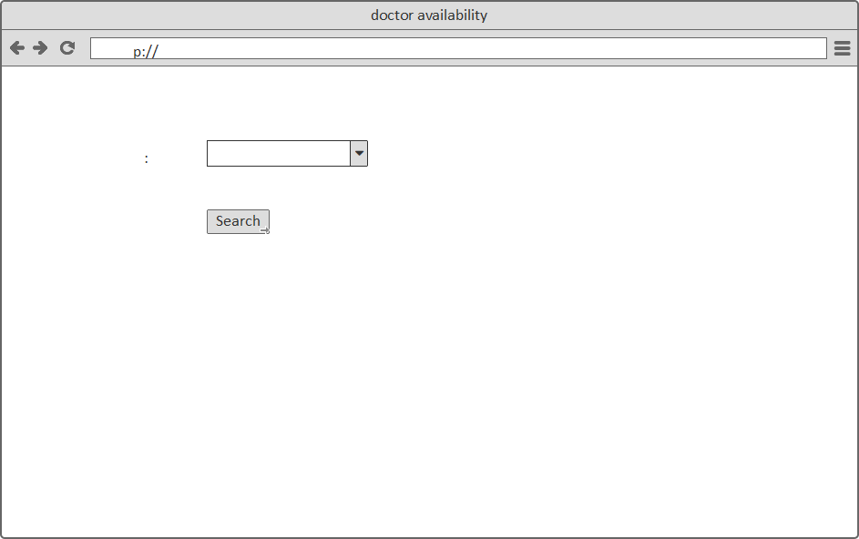Check Doctor Availability

D htt www.hospital/doctor

Select Department Orthopedics

book opponent

https

Orthopedic Doctors

##### Name:

Available Time:

0 12:00 PM — 12:30 PM

0 12:30 PM — 01:0 PM

#### 0 01: 00 PM — 01:30PM

##### 0 01:30 PM — 02. 0 PM

Name:

Available Time:

##### Name:

Available Time:

0 Radio Button 0 Radio Button

0 Radio Button O Radio Button

##### Name:

Available Time:

##### Name:

Available Time:

##### Name:

Available Time:

Patient Registration

°

D [htte://www.hm8.com/patiRntregistration/](http://www.hm8.com/patiRntregistration/)

Patient Registration

## NEW PATIENT REGISTRATION

— Patient Information

Patient Name:

*Age:*

Sex: Marital Status:

Blood Group:

O Male

O Married

O Female

O Single

Department:

Address:

mobile:

•

Orthopedic s





|  |  |
| --- | --- |
| Plot no | Street |
|  |  |
| City | State |
|  |  |
| Post Code |
|  |
|  |

submit

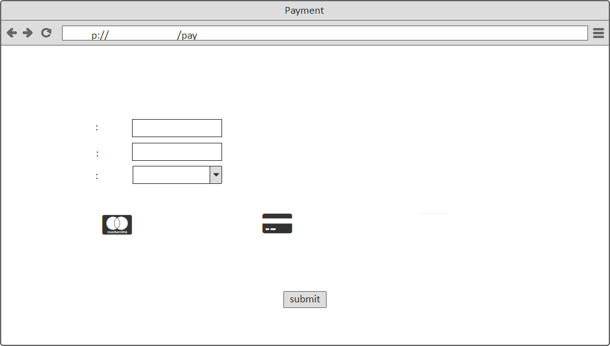Make Payment

& htt \v\v\v.hms.com ment

MAKE PAYM ENT

Patient Name

Unique Patient I D

Select Fee Option

Registration fee

O master card

O Credit card

O Cash

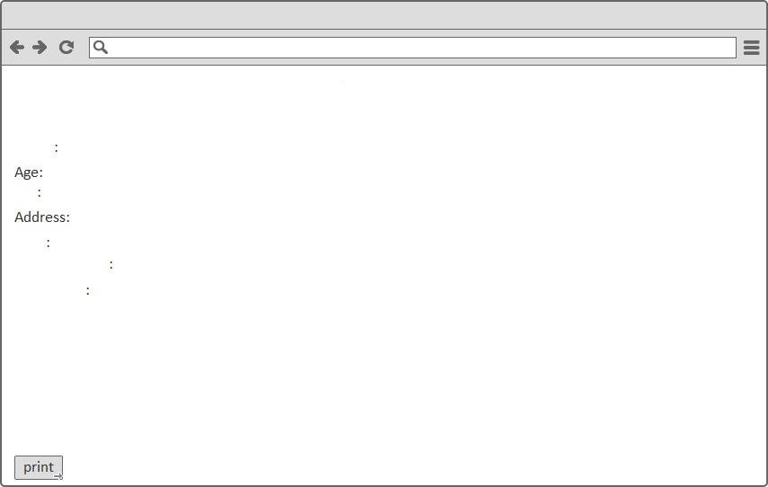Take print

Print Form

Name Sex

Date

Consult doctor Fee Details

###### registration successful

& htt \v\v\v.hms.com /situation

Patient successfully registered/UPID generated

Unique Patient I D

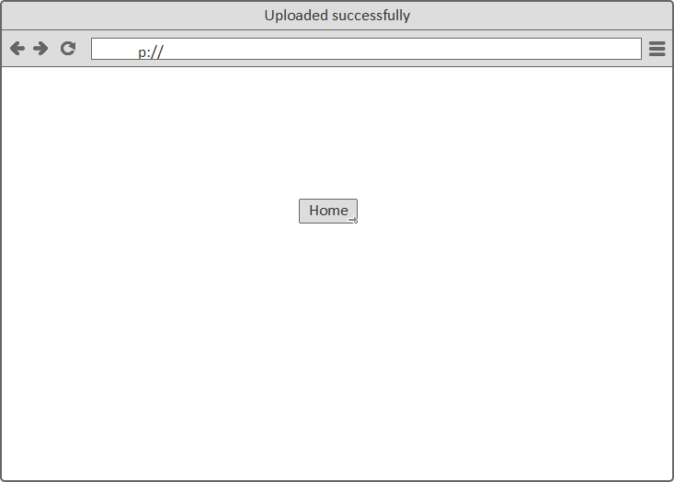Upload

D htt

UPLOADED LAB REPORTS SUCCESSFULLY